IdeationPhase

DefinetheProblemStatements

|  |  |
| --- | --- |
| Date | 2 November 2022 |
| TeamID | PNT2022TMID26417 |
| ProjectName | VirtualEye-LifeGuardforSwimmingPoolstoDetectActiveDrowning |
| MaximumMarks | 2Marks |

Problemstatements:

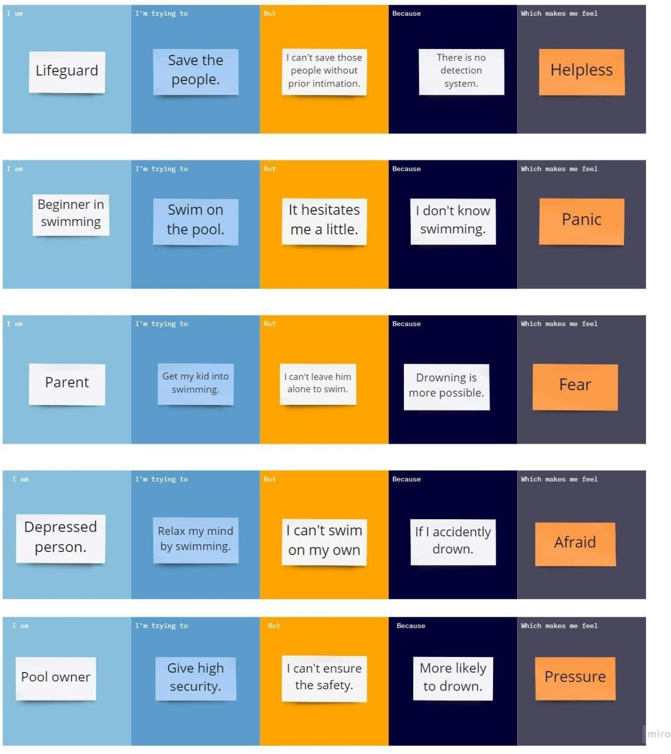

PROBLEM-4

PROBLEM-5

PROBLEM-3

PROBLEM-2

PROBLEM-1